**Modern apps**

High data scale

High usage scale

Clous based costs

**Scaling**

* Vertical scaling – increase power of hardware
* Horizontal scaling -

**Practical problem**

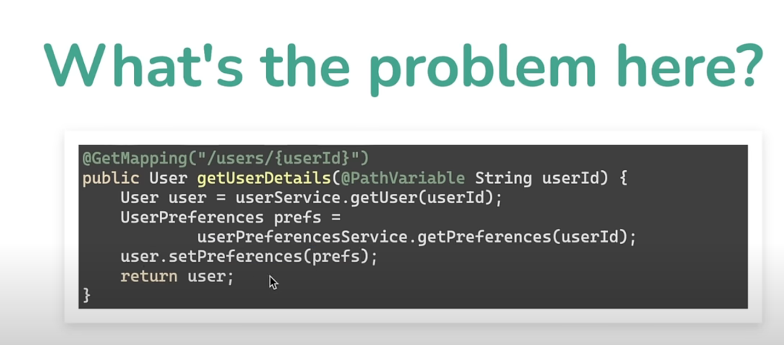

Impacts cost and performance

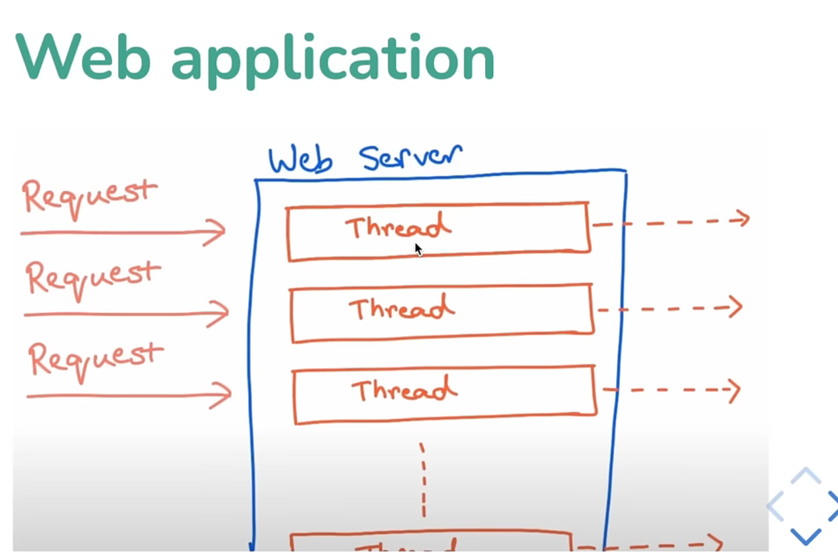

Idlying threads – wasted hardware

**Future API**

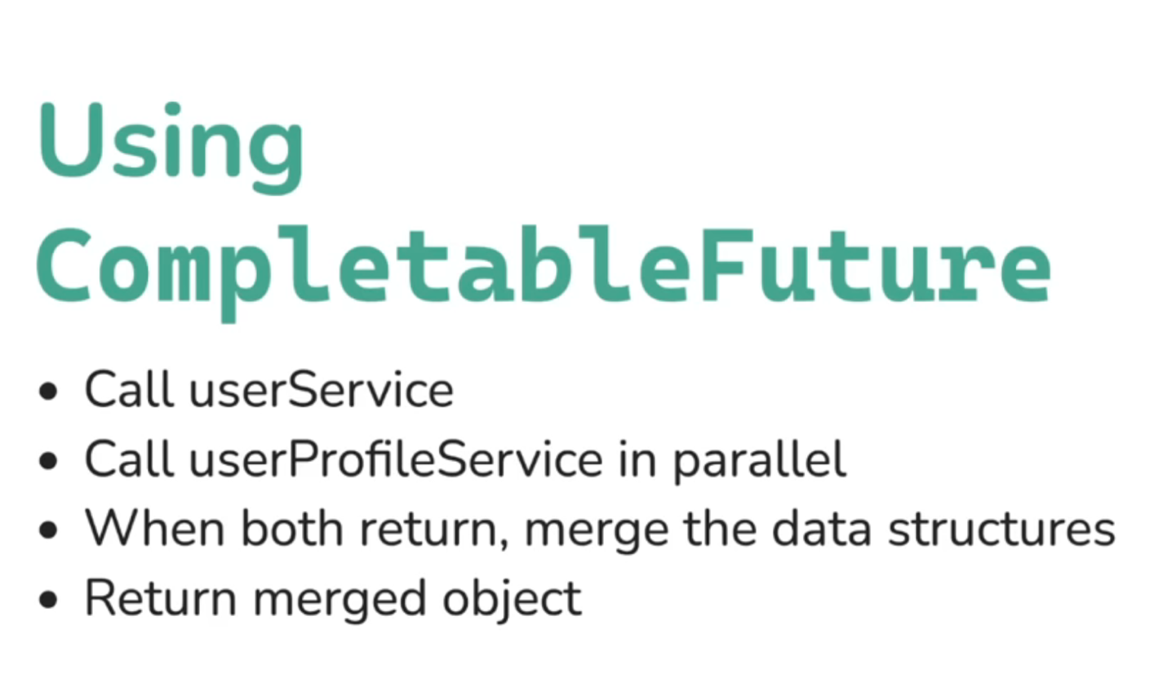

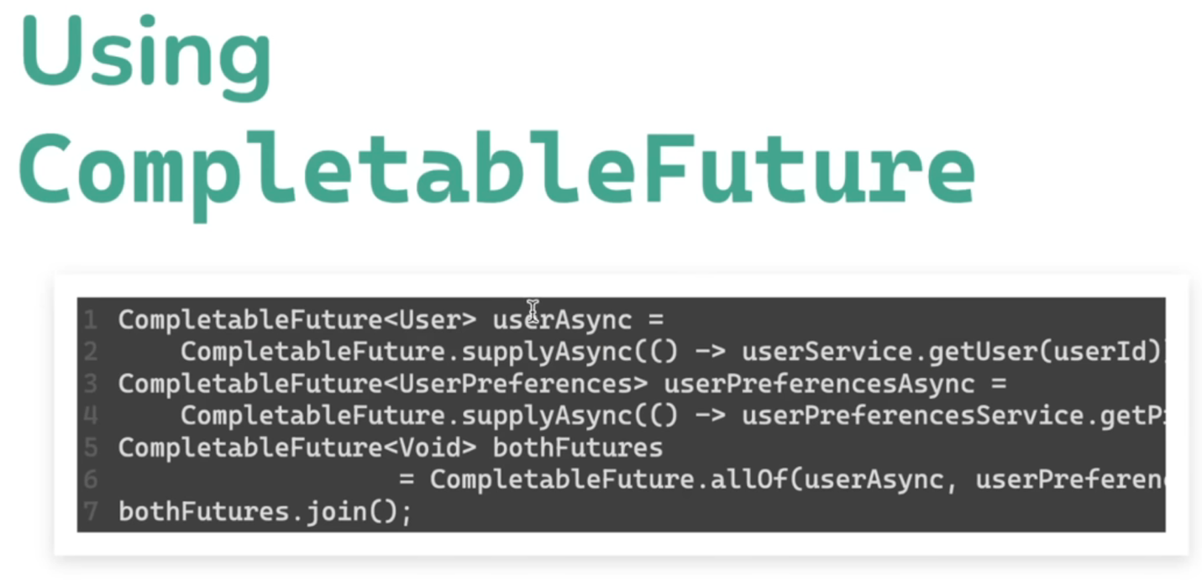

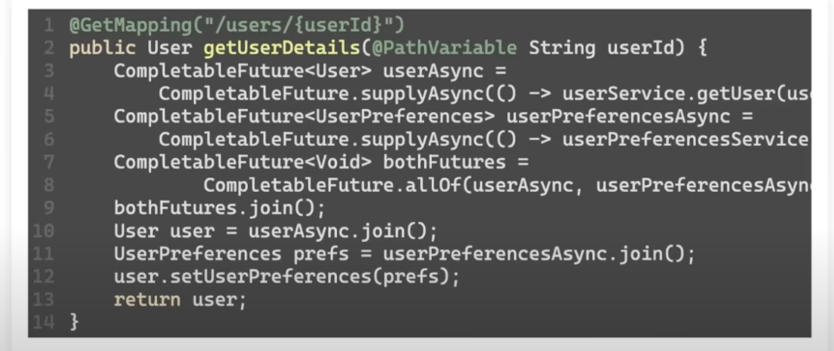

Join is blocking in above code-base as we are returning type of user, but not type of CompletableFuture

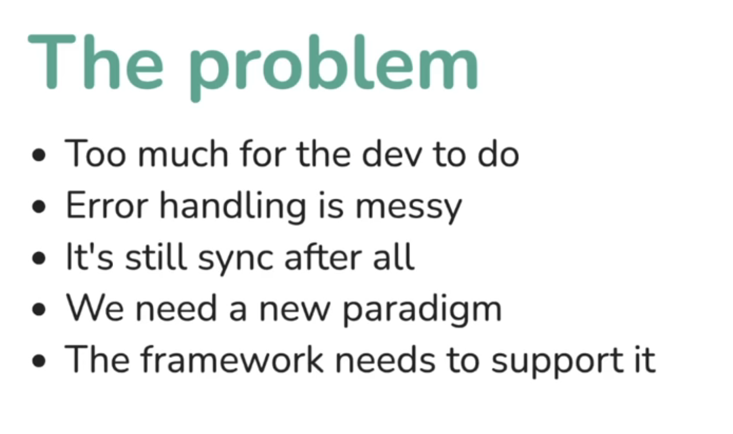

**Reactive-Programming**

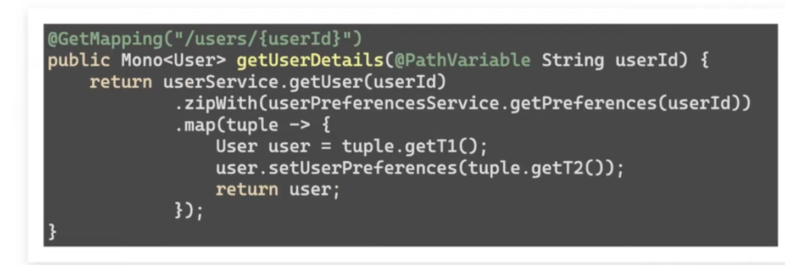

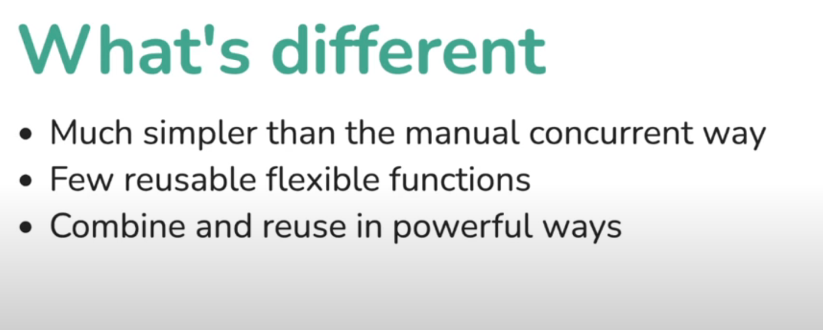

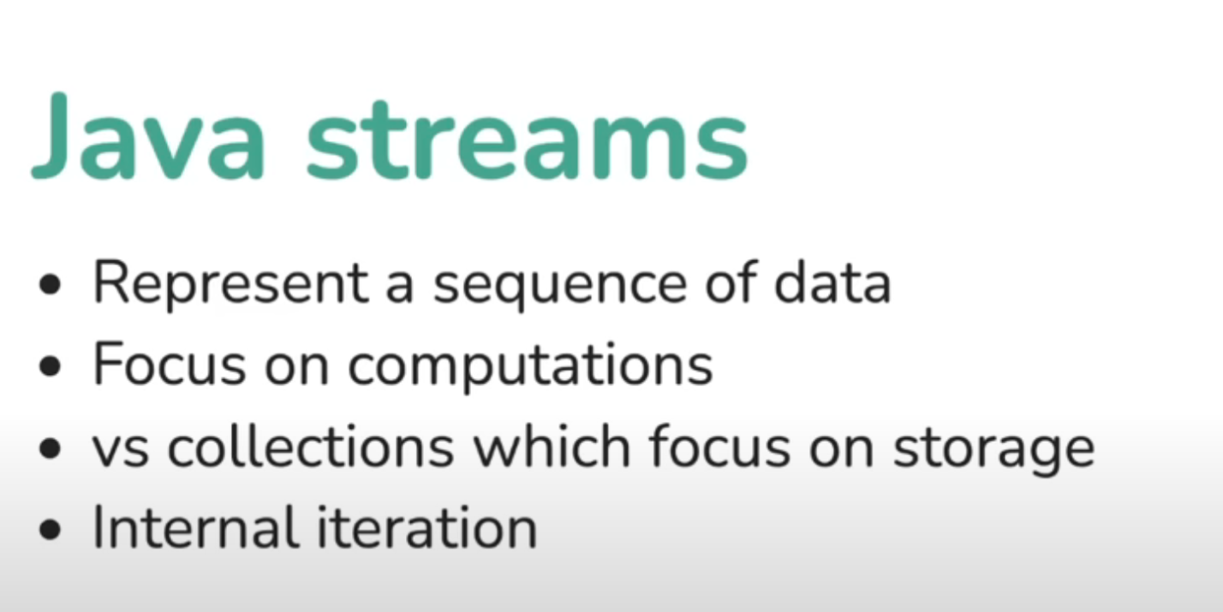

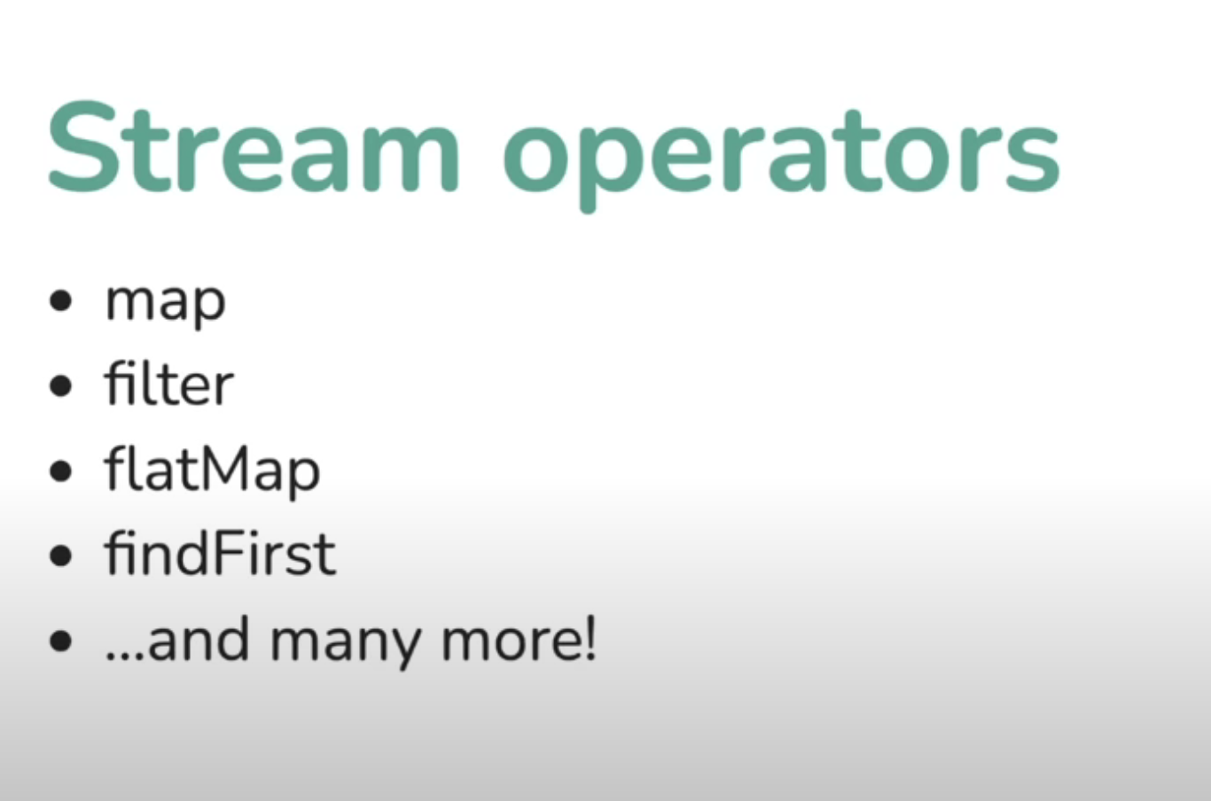

* If RHS of map is value, then use map
* If RHS of map is a stream, then use flat map

UserStream.map(user->user.getFirstName());

UserStream.flatMap((id->Streamsources.userStream().filter(user->user.getId()==

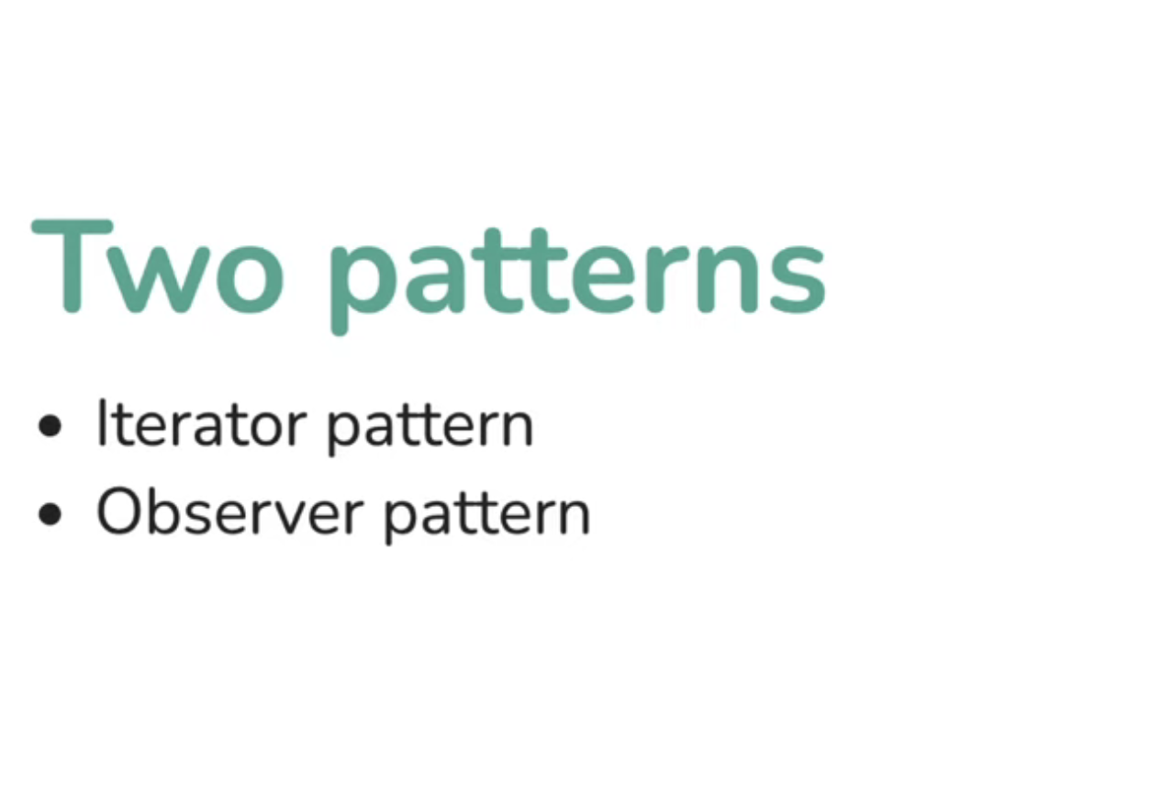

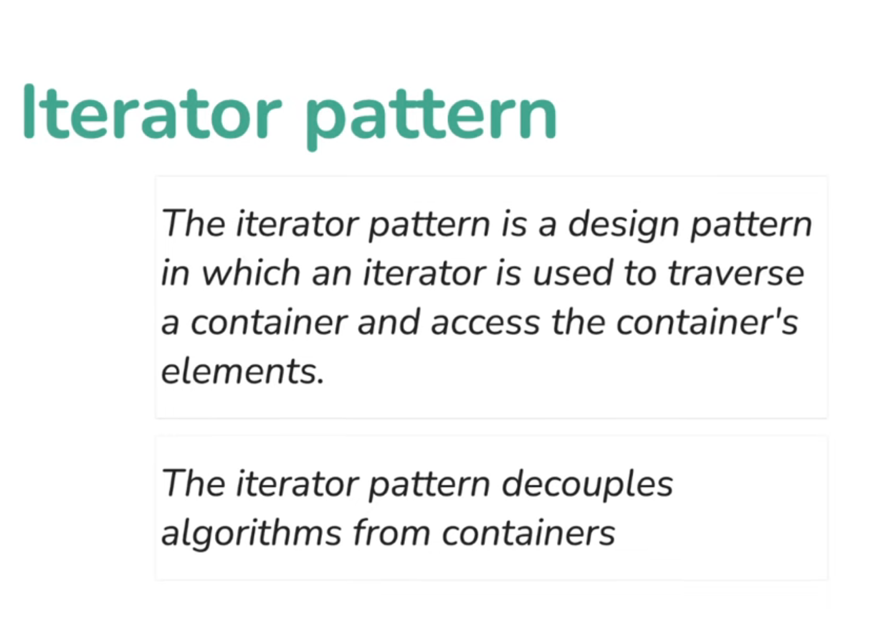

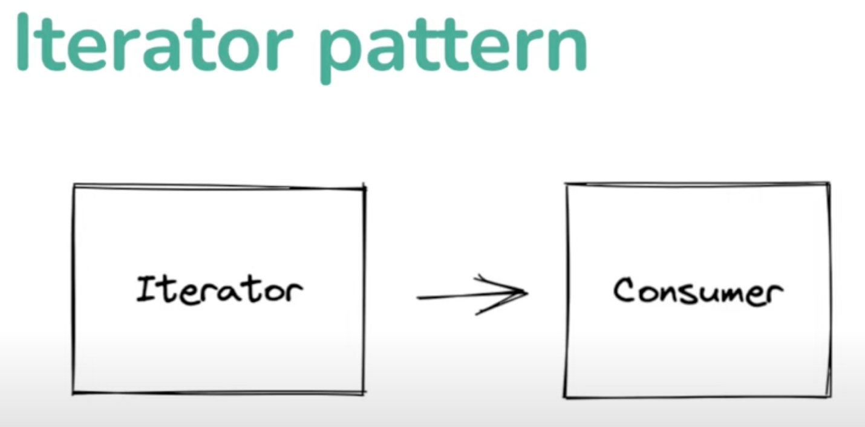

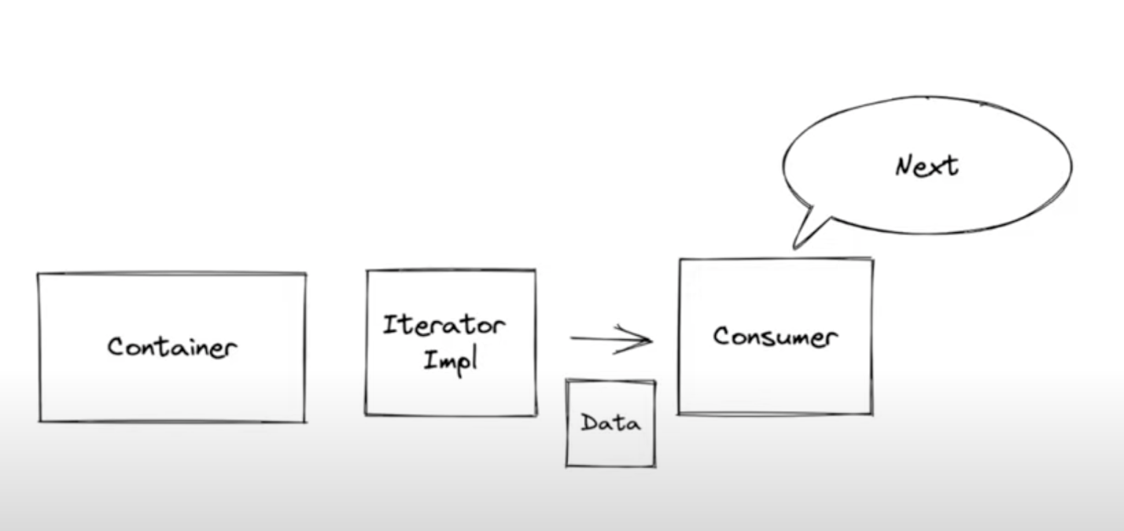

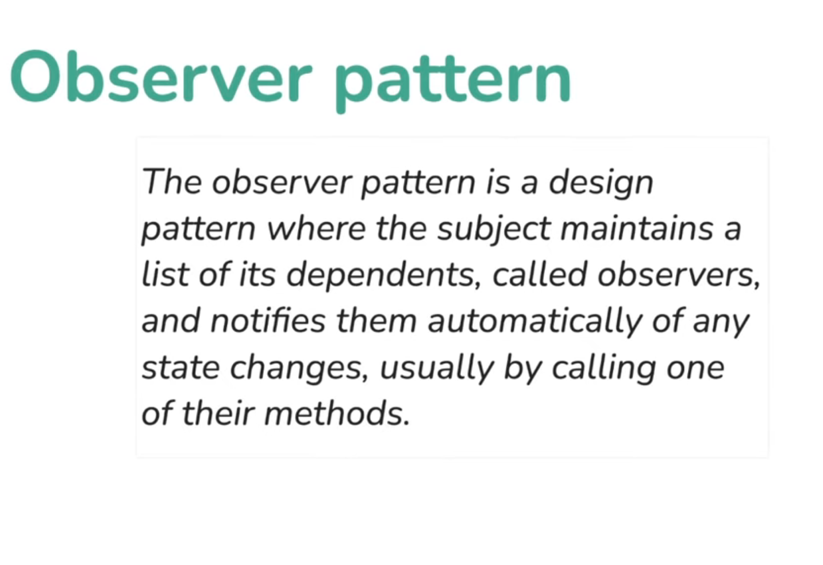

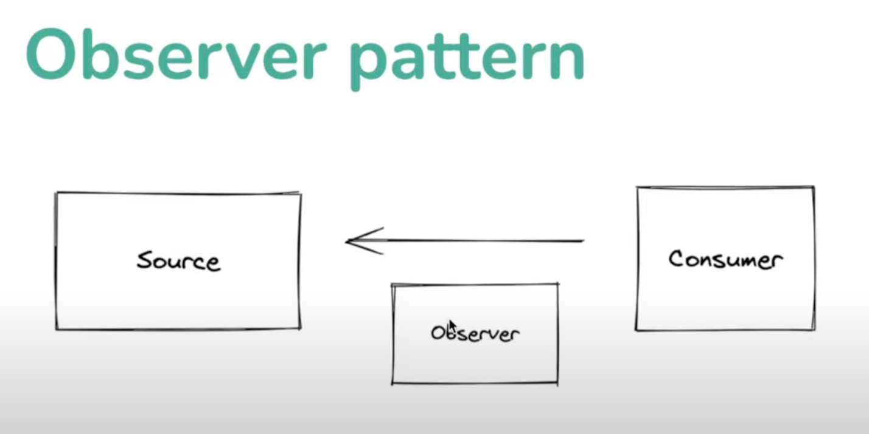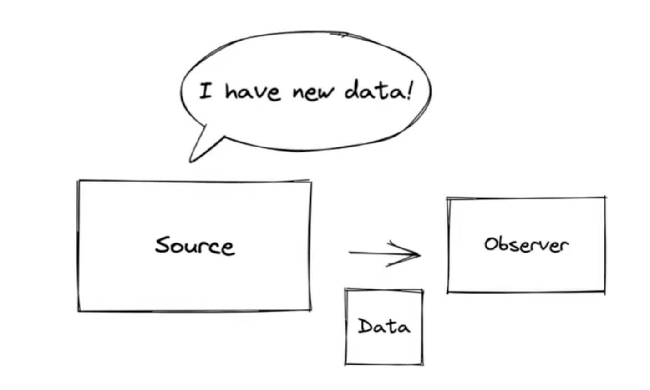

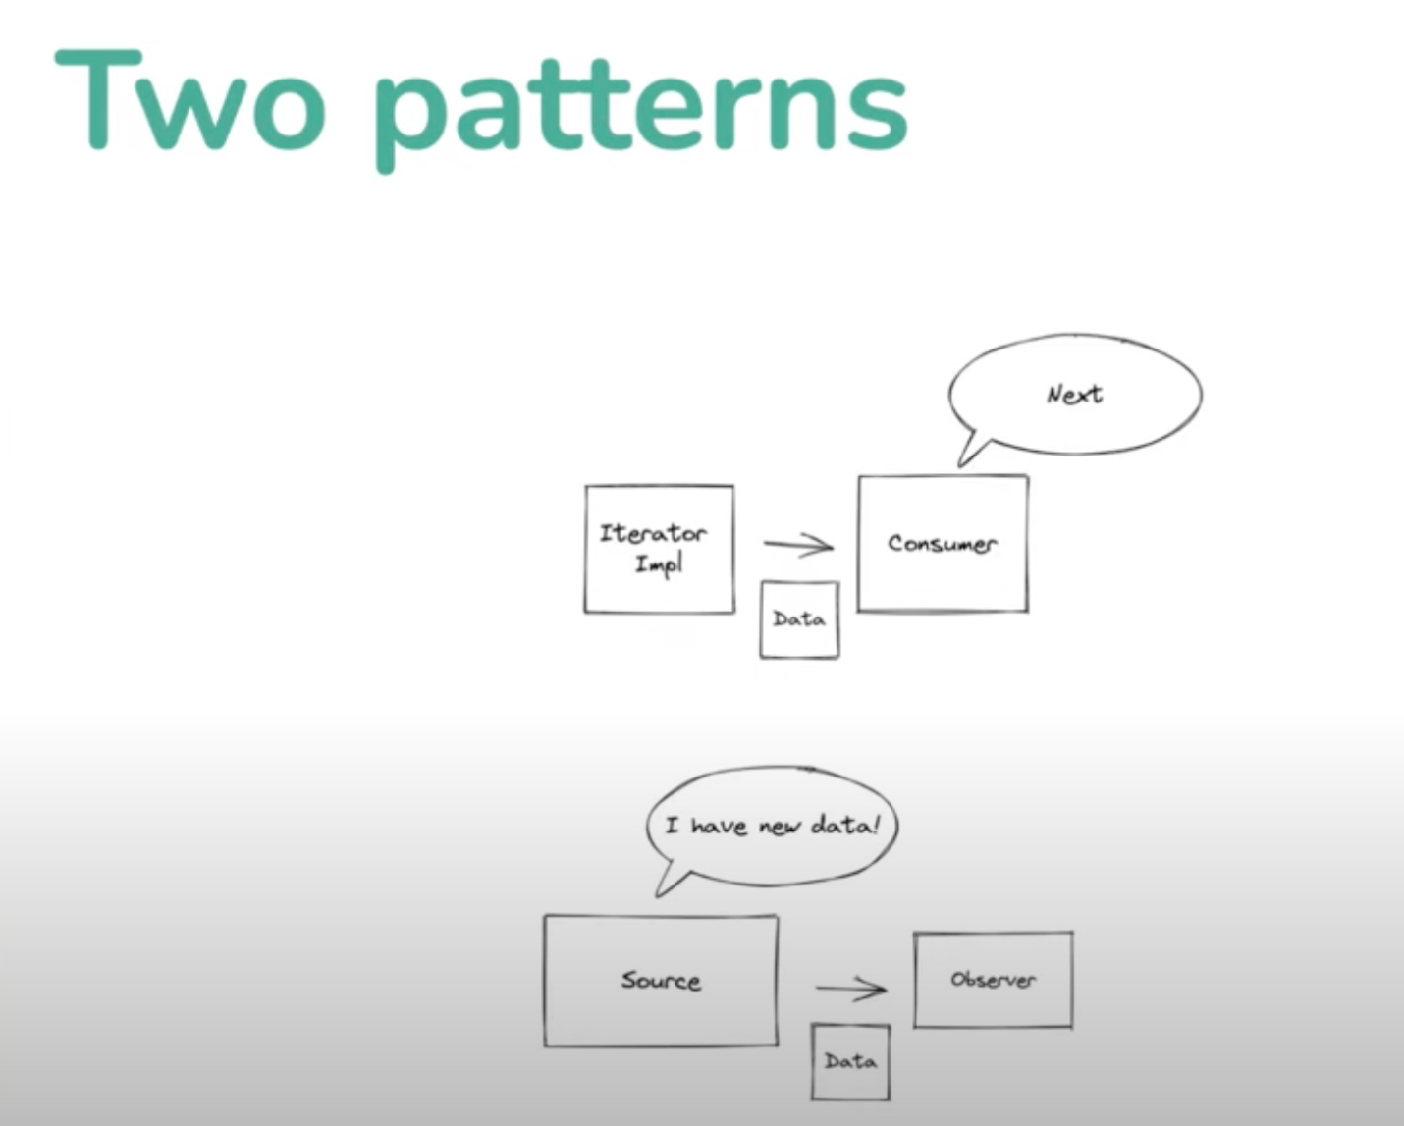

Consumer controls in iterator pattern

Source controls in Observer pattern

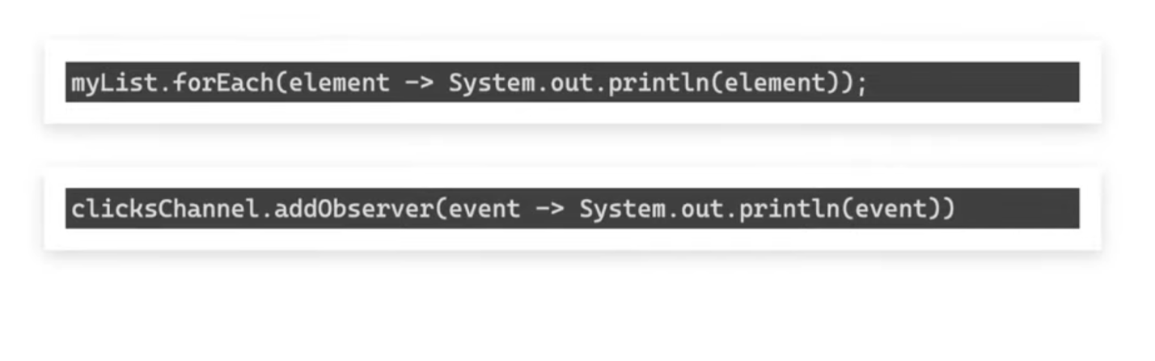

Iterator pattern – myList.forEach(element->system.out.println(element));

Observer pattern – clicksChannel.addObserver(event-> system.out.println(element));

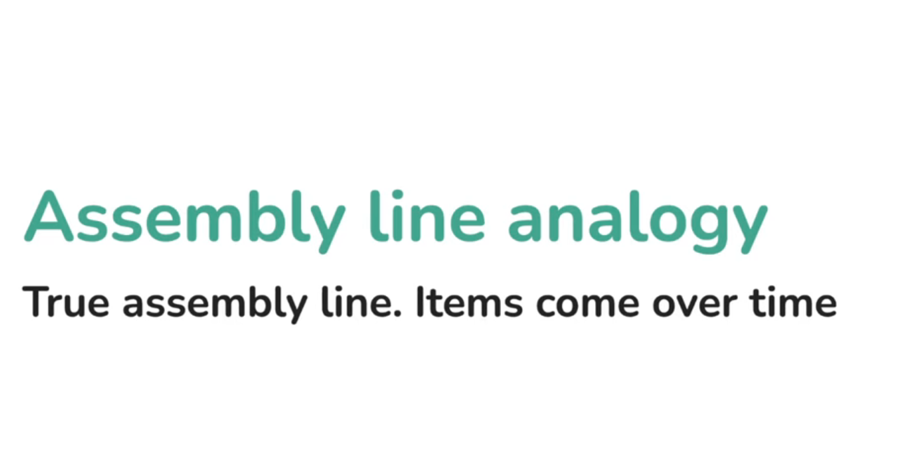

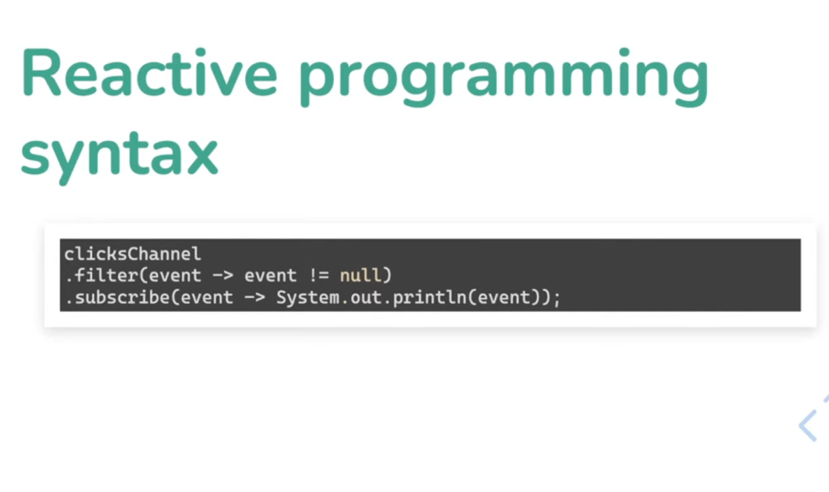

* Subscribe is similar to forEach in streams- whenever an event happens , do this operation
* Flux acts as source in observer pattern

Flow API is started in Java9



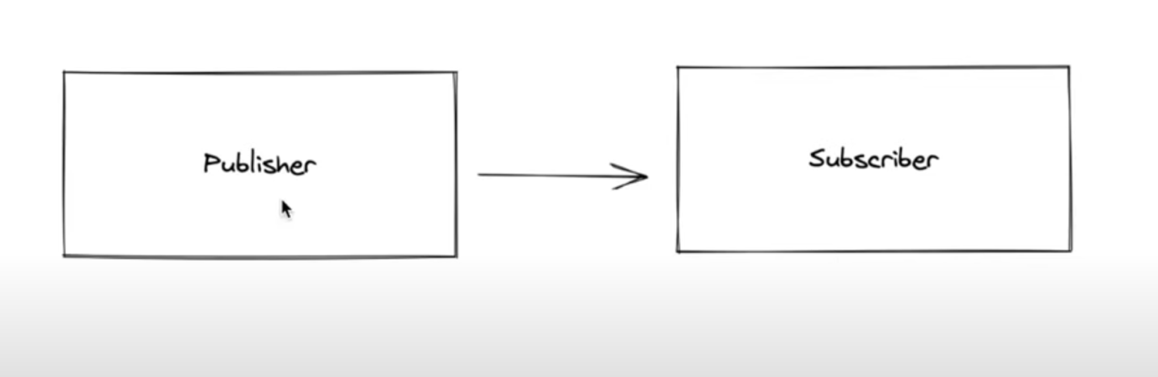

* Flux is a publisher
* Integer value = ReactiveSources.intNumberMono().block();
* In reactive world, subscribe is similar to forEach
* Flux/Mono is the publisher and we do

ReactiveSources.*intNumbersFlux*().subscribe(e-> System.*out*.println(e));

i.e publisher.subscribe(e-> System.*out*.println(e));

* Mono is asynchronous sequence of zero/one item
* Flux is asynchronous sequence of zero/n items

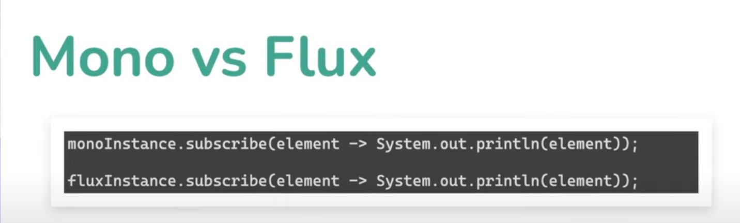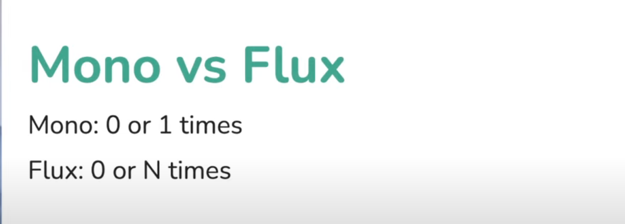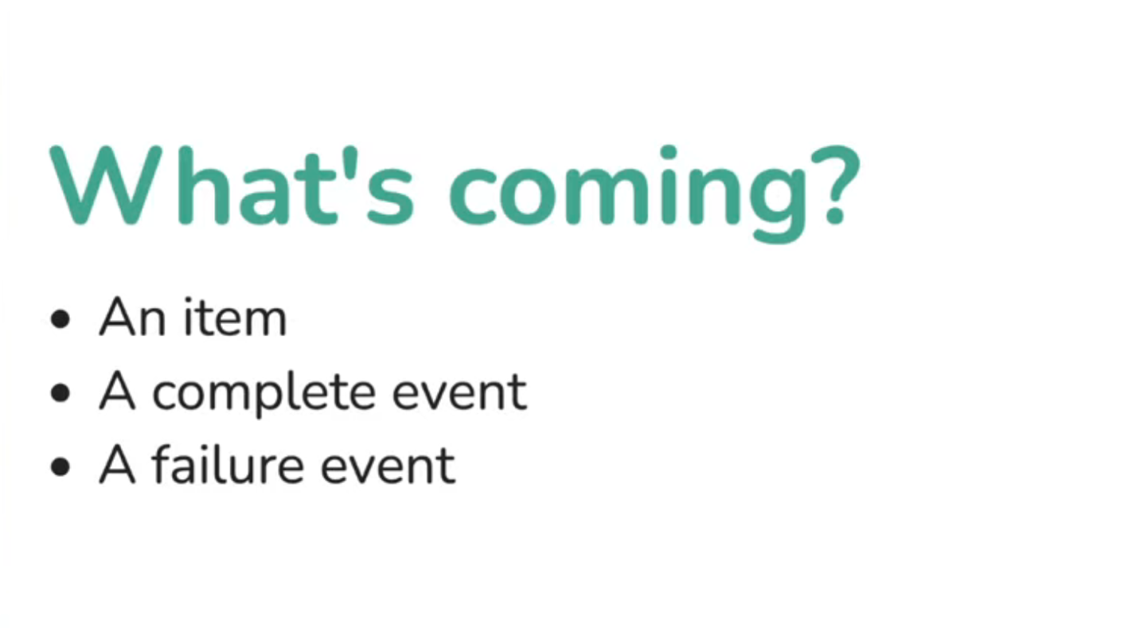

2 and 3 are terminal events

Mono can send only complete event/failure event

Flux can send item first and comple event

Bunch of items and failure event

* Incase of flux, sometimes subscriber may not be able to process all the messages (because of speed) received, which may lead to backpressure.

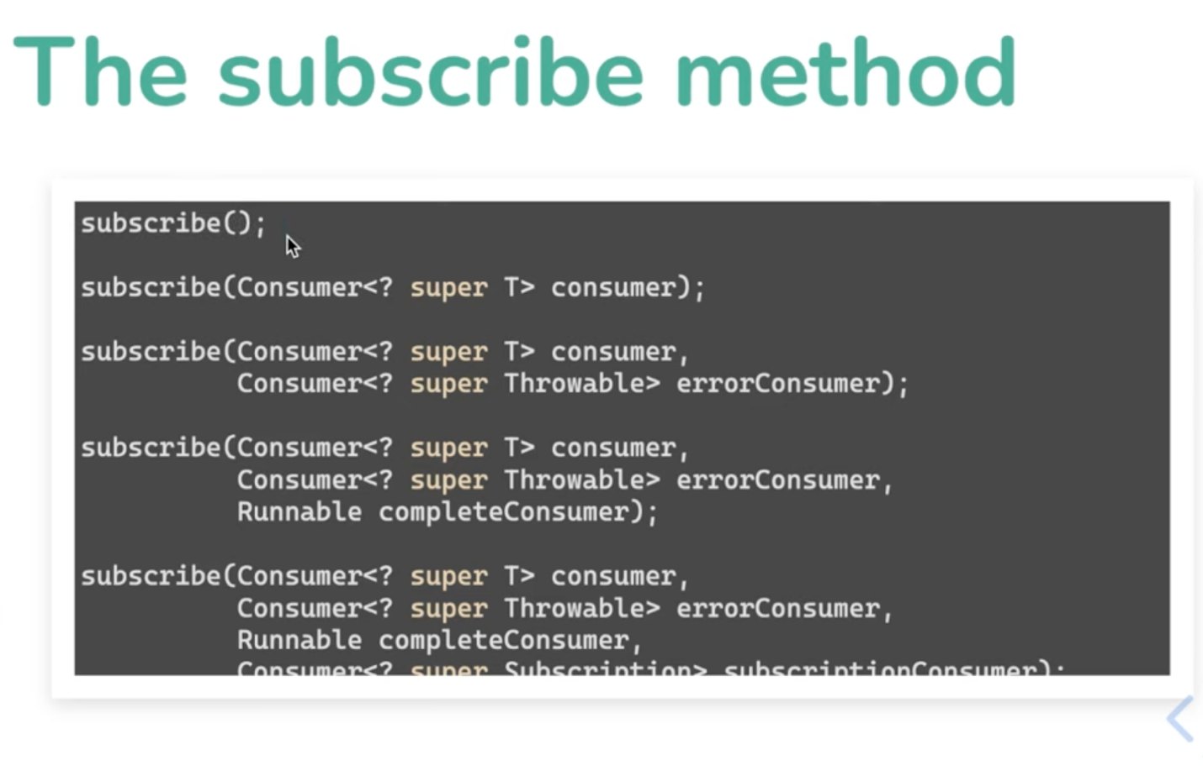

* ReactiveSources.*intNumbersFlux*().  
   subscribe(  
   number-> System.*out*.println(number),  
   err-> System.*out*.println(err.getMessage()),  
   ()-> System.*out*.println("complete"));

Base-subscriber has a class that can replace all the above 3 lambdas and get the work done

* Blocking to get value

Integer value = ReactiveSources.intNumberMono().block();

* Another way of doing subscribe, but useful to control rate of flow to handle back-pressure control

**Blocking to get value**

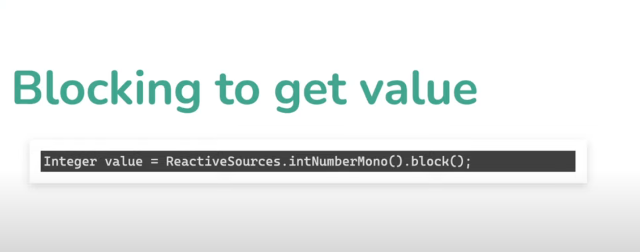

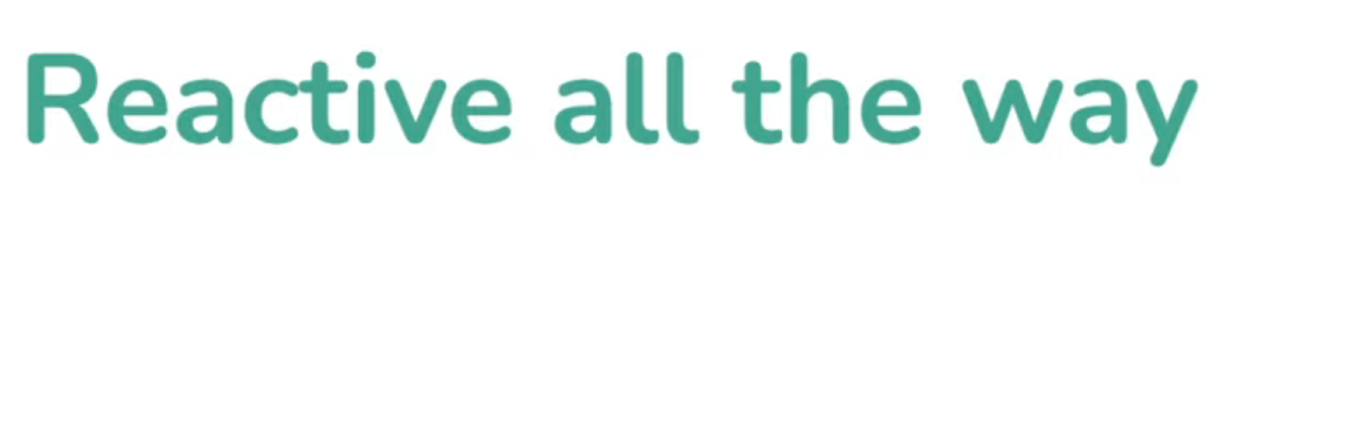

Web app

1. Http request comes and it needs to wait on and all other flows can be reactive.
2. Reactive web-server is netty
3. Netty will be given Mono and ask to respond to http-request whenever the mono callsback
4. No threads waiting on web-servers.
5. Netty can go on 100k simultaneous req(on good cloud hardware) as no threads are waiting on

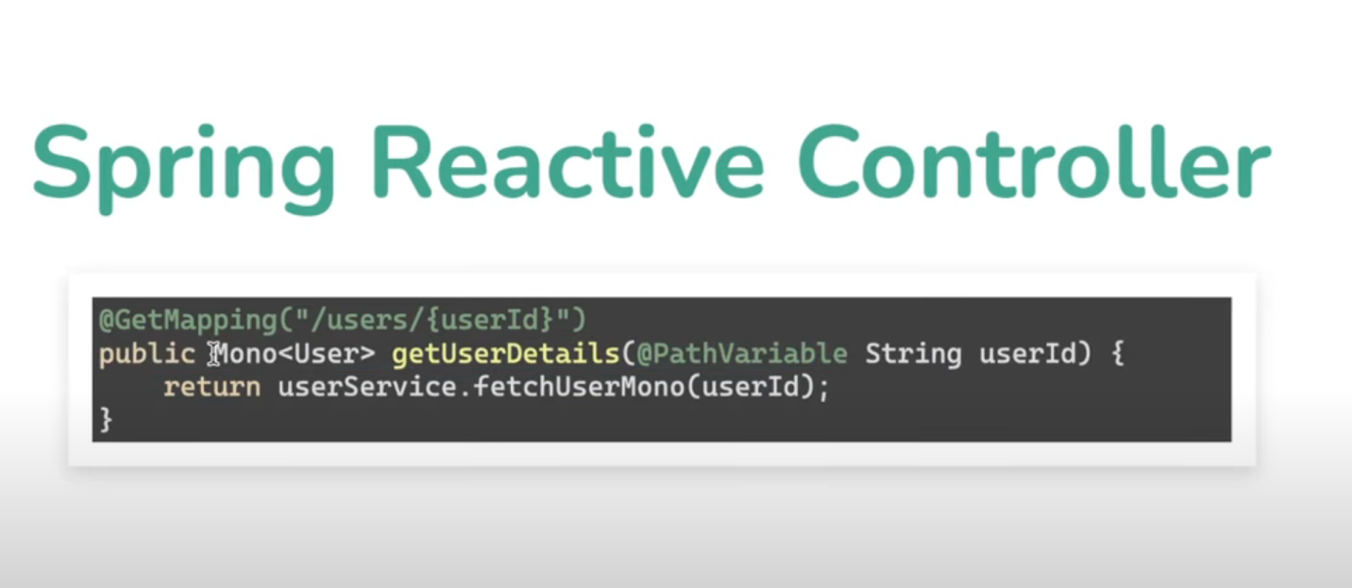

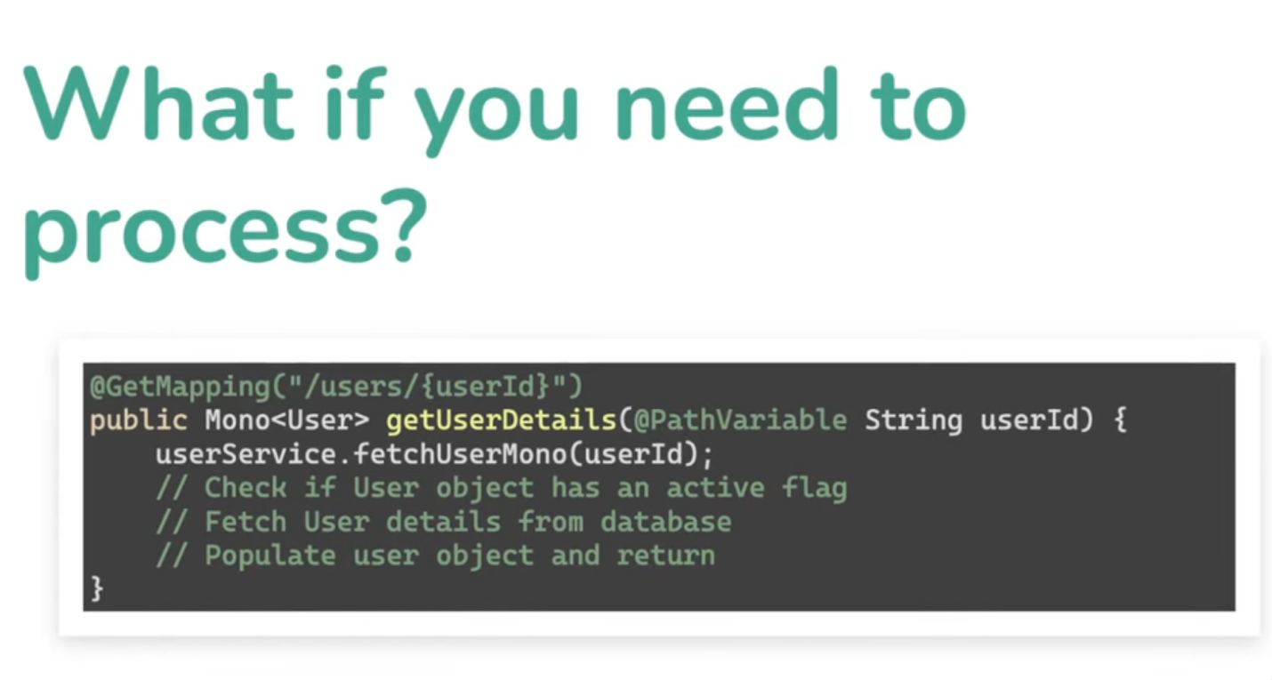

We can’t use subscribe on getUserDetails as subscribe is kind of block

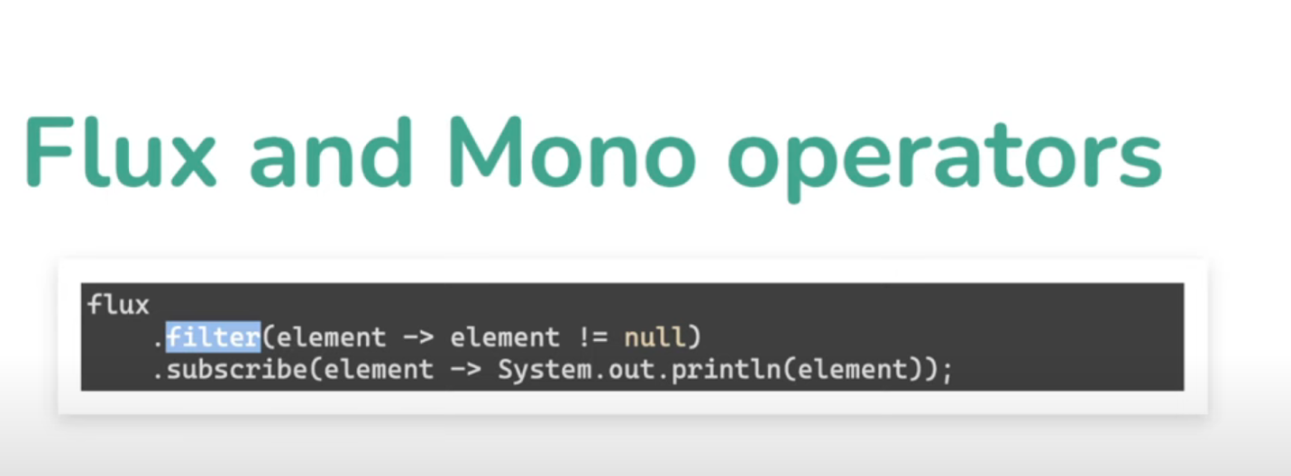

Subscribe executes only when an event comes in from the flux returned by filter

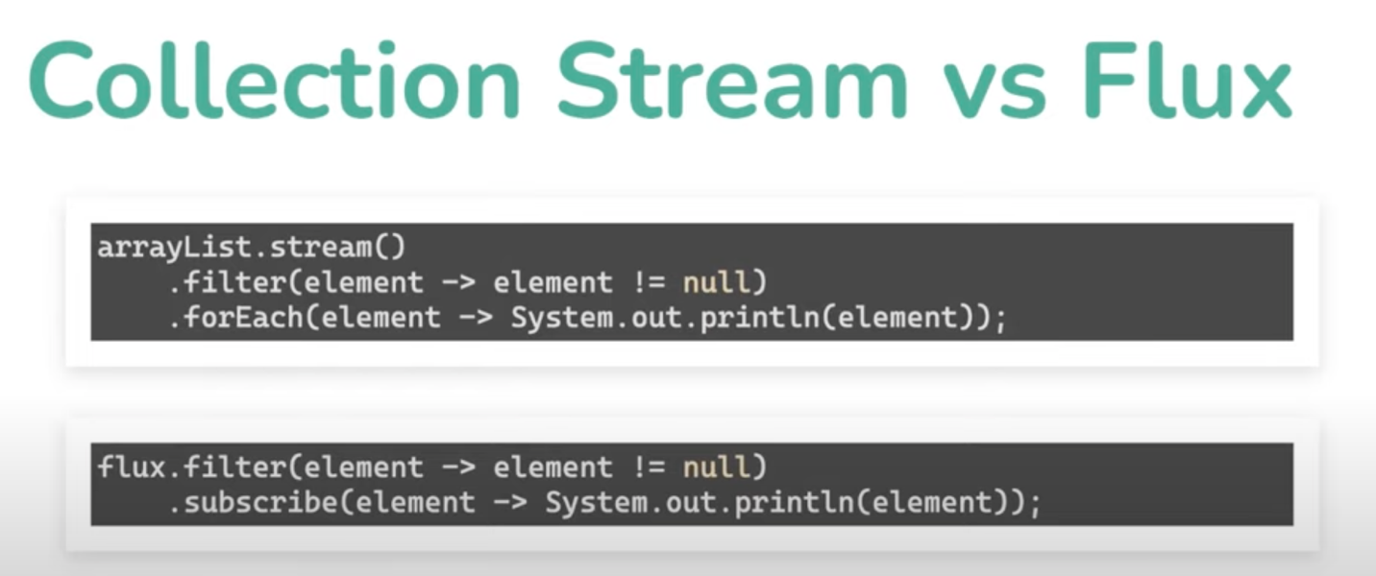

* .log() always needs subscribe to print the elements
* .log() is used to debug the reactive flow – it returns a flux

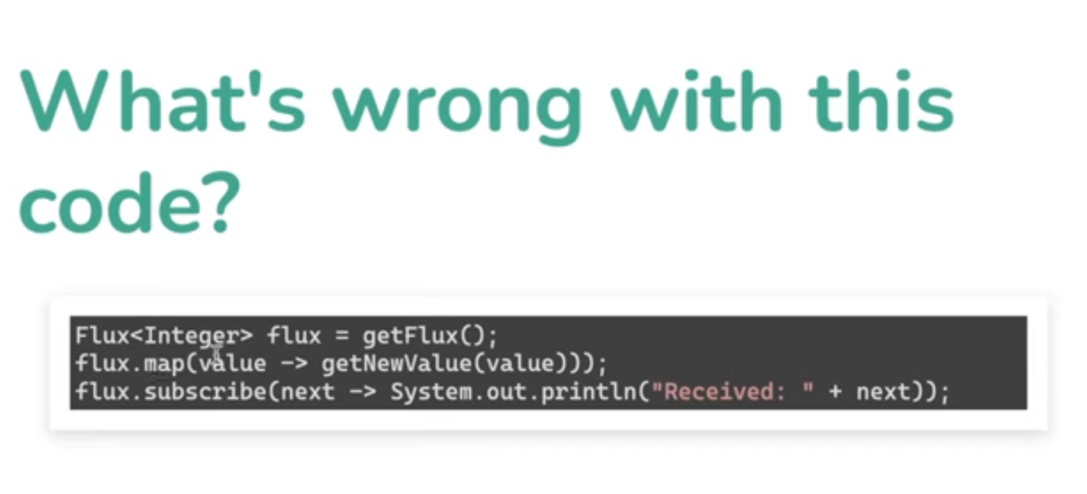

Anytime we do an operator, we either chain it or apply it to right flux, here

Flux.map is ignored in the flow as it’s a completely new flux

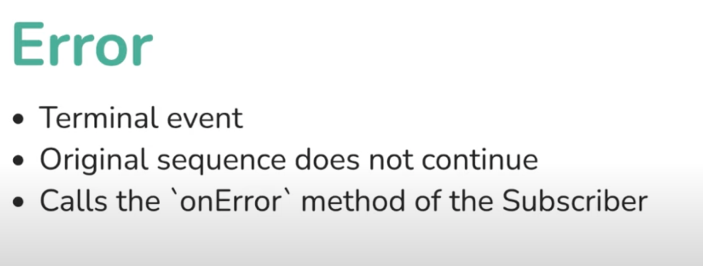

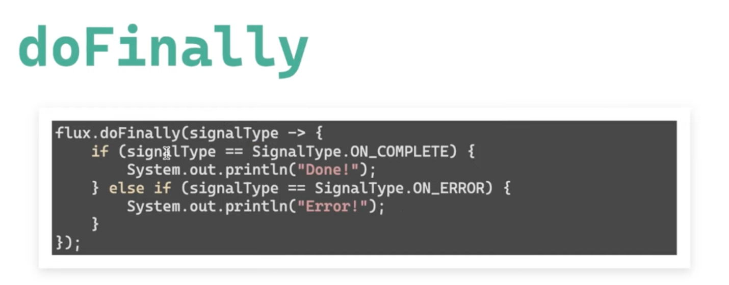

Analogous to finally block in java

Why webflux

* If you are already shopping for a non-blocking web stack, Spring WebFlux offers the same execution model benefits as others in this space and also provides a choice of servers (Netty, Tomcat, Jetty, Undertow, and Servlet containers), a choice of programming models (annotated controllers and functional web endpoints), and a choice of reactive libraries (Reactor, RxJava, or other).
* If you have a Spring MVC application with calls to remote services, try the reactive WebClient. You can return reactive types (Reactor, RxJava, [or other](https://docs.spring.io/spring-framework/reference/web-reactive.html#webflux-reactive-libraries)) directly from Spring MVC controller methods. The greater the latency per call or the interdependency among calls, the more dramatic the benefits. Spring MVC controllers can call other reactive components too.

In Spring MVC (and servlet applications in general), it is assumed that applications can block the current thread, (for example, for remote calls). For this reason, servlet containers use a large thread pool to absorb potential blocking during request handling.

In Spring WebFlux (and non-blocking servers in general), it is assumed that applications do not block. Therefore, non-blocking servers use a small, fixed-size thread pool (event loop workers) to handle requests.

|  |
| --- |
| “To scale” and “small number of threads” may sound contradictory, but to never block the current  thread (and rely on callbacks instead) means that you do not need extra threads, as there are no  blocking calls to absorb. |

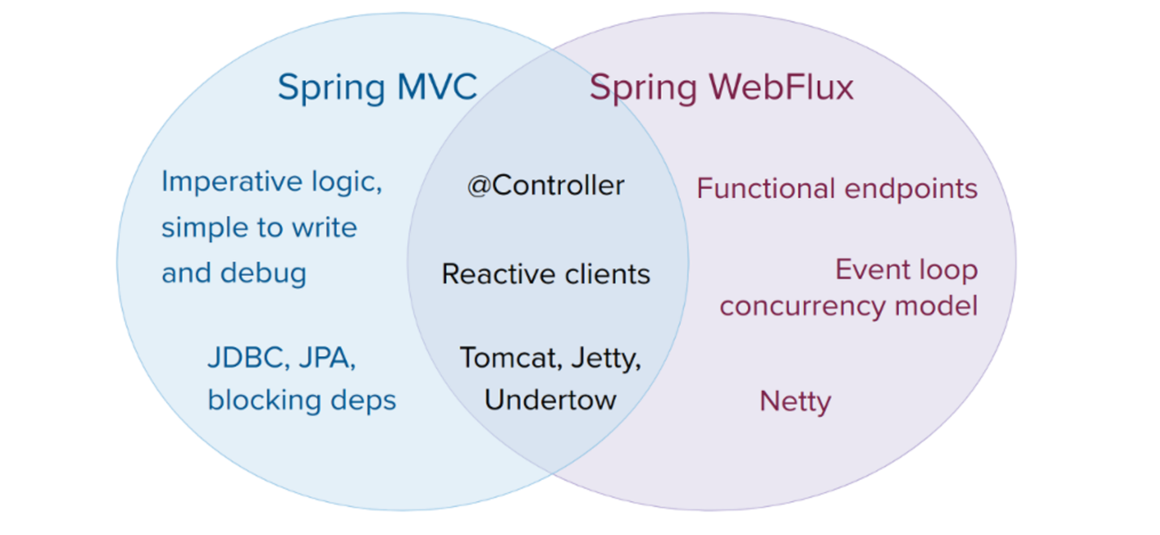

**Invoking a Blocking API**

What if you do need to use a blocking library? Both Reactor and RxJava provide the publishOn operator to continue processing on a different thread. That means there is an easy escape hatch. Keep in mind, however, that blocking APIs are not a good fit for this concurrency model.

### Mutable State

In Reactor and RxJava, you declare logic through operators. At runtime, a reactive pipeline is formed where data is processed sequentially, in distinct stages. A key benefit of this is that it frees applications from having to protect mutable state because application code within that pipeline is never invoked concurrently.